**Statistics Assignment – 1**

Que 1) Plot a histogram,

Data = { 10, 13, 18, 22, 27, 32, 38, 40, 45, 51, 56, 57, 88, 90, 92, 94, 99}

The data is already sorted.

Specifying the bin size = 20

Que 2) In a quant test of the CAT Exam, the population standard deviation is known to be 100. A sample of 25 tests taken has a mean of 520. Construct an 80% CI about the mean.

Population Standard deviation = 100

n = 25

x = 520

Confidence interval = 80% = 0.8

Significance value = 1 – C.I

= 1 – 0.8

= 0.2

Z(0.2/2) = Z(0.1)

* 1-0.1 = 0.9

Z(0.9) = -1.29 – 1.29

Lower fence = 494.2

Higher fence = 545.8

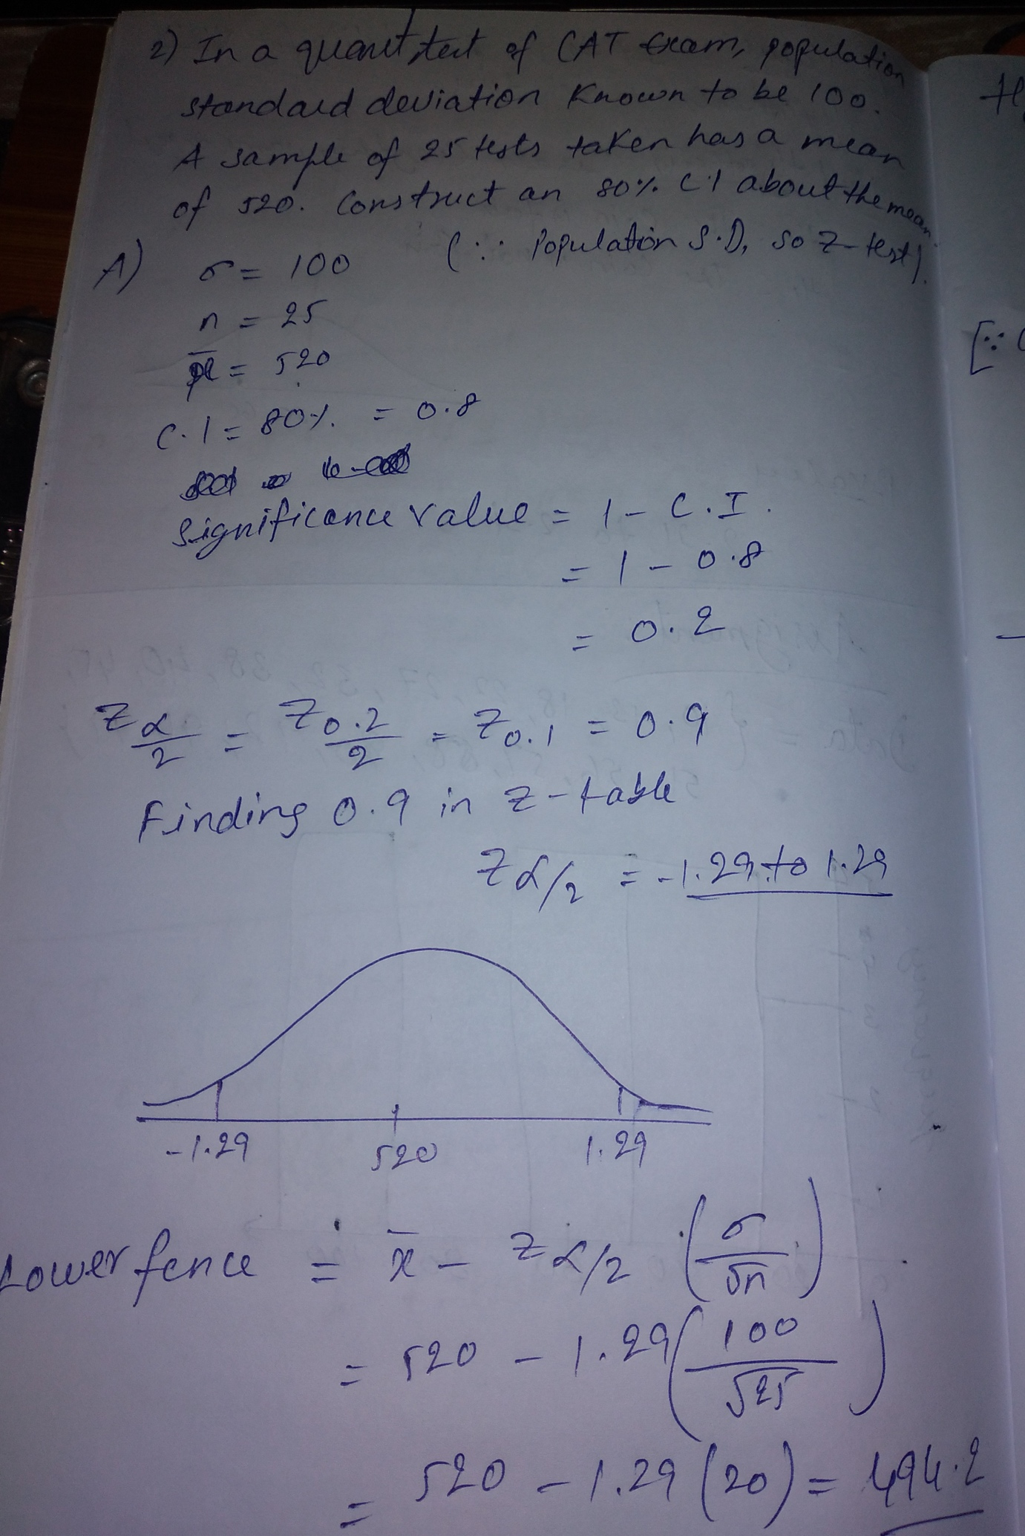

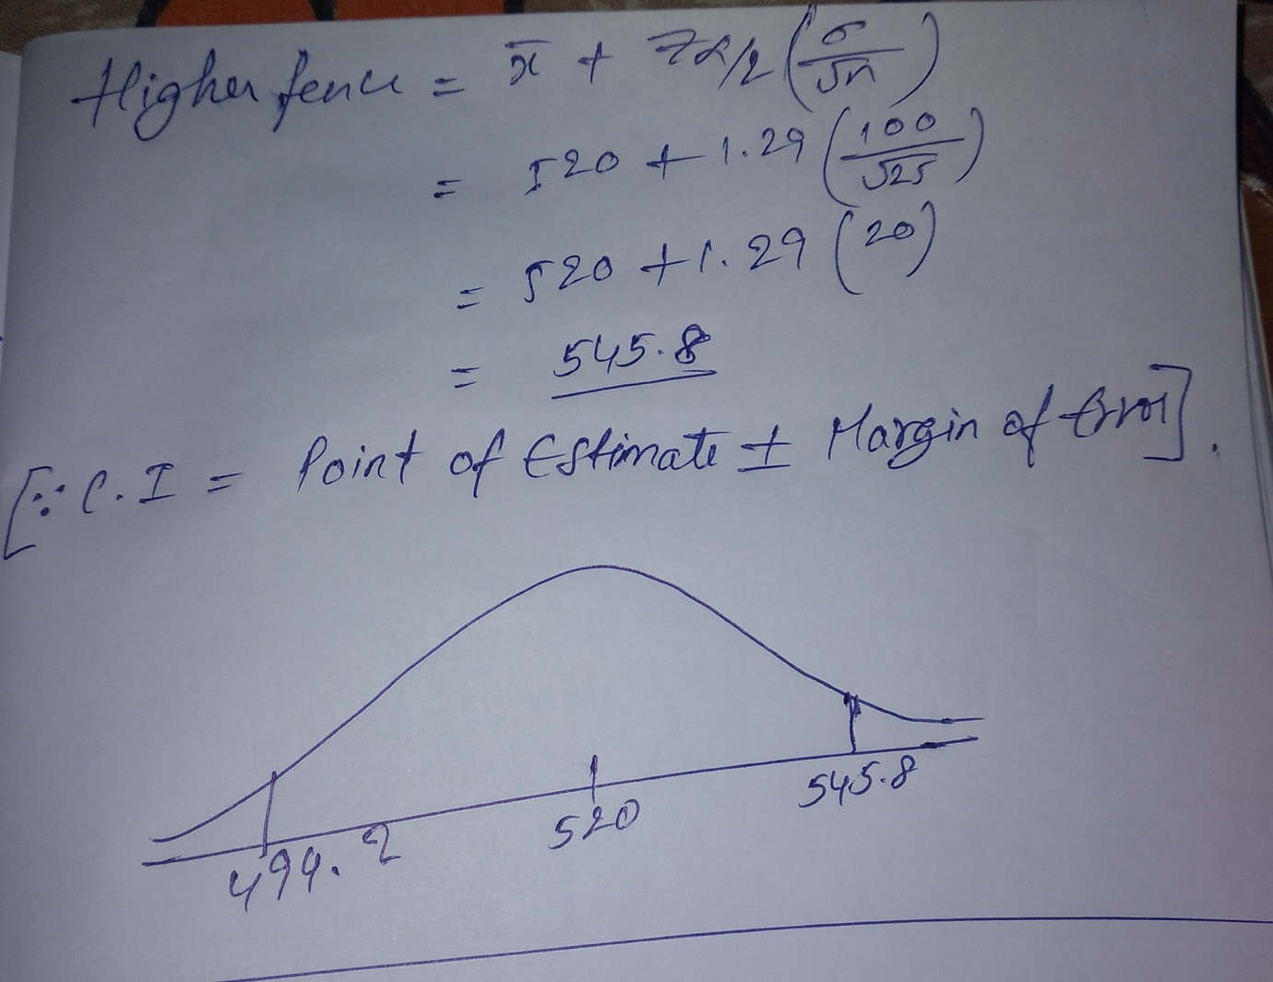

Que 3) A car believes that the percentage of citizens in city ABC that owns a vehicle is 60% or less. A sales manager disagrees with this. He conducted a hypothesis testing surveying 250 residents & found that 170 residents responded yes to owning a vehicle.

1. State the null & alternate hypothesis.
2. At a 10% significance level, is there enough evidence to support the idea that vehicle owner in ABC city is 60% or less.
3. n = 250

x = 170

H0 = 60%(Owns a vehicle not less than 60%)

H1 < 60%(Owns a vehicle less than 60%)

Significance value = 0.10

**Decision boundary:**

Z(0.10/2) = Z(0.05) = 0.95

Z(0.95) = 1.65

If Z-value is less than 1.65 then H1 is true.

Z-value is 2.66

Accept H0.

Conclusion: there is not enough evidence to support the idea that vehicle owner in ABC city is 60% or less. Vehicle owners are not less than 60%

Que 4) What is the value of the 99 percentile?

2,2,3,4,5,5,5,6,7,8,8,8,8,8,9,9,10,11,11,12

* 99/100*(n+1)
* [n=20]
* 99/100*(21)
* 20.79 = 12

Que 5) In left & right-skewed data, what is the relationship between mean, median & mode?

Draw the graph to represent the same.

In right skewed data, mean > median > mode

In left skewed data, mean < median < mode

As we take an example: Average No. of employees working in IT profession are high compared to No. of employees working in Mechanical and Civil profession

